# **Propensity Score Analysis to Match Intervention Kids to Non-Intervention**

## **Introduction:**

It is often unethical to use random assignments in areas where important research or constructs are being carried out. Propensity Score Analysis is a method of reducing selection bias in estimating treatment effects by reducing many pre-treatment covariates to a single scalar function and matching and allows researchers to compare subjects with similar probability to receive the treatment. Our analysis is based on the assumption that students are chosen for a particular treatment based on their background characteristics.

We use the propensity score to model the relationship between pretreatment variables and treatment assignment which is the conditional probability of assignment to treatment based on measured pretreatment analysis. In our analysis, we have used the birth age of the individual, age of the individual at removal, congregate care type, number of placements, number of removals, sex and race as our pre-treatment covariates to match the kids who have received treatment to those who have not received treatment.

## Procedure followed:

The code is written in R using the MatchIt package and follows the flowchart as shown below:

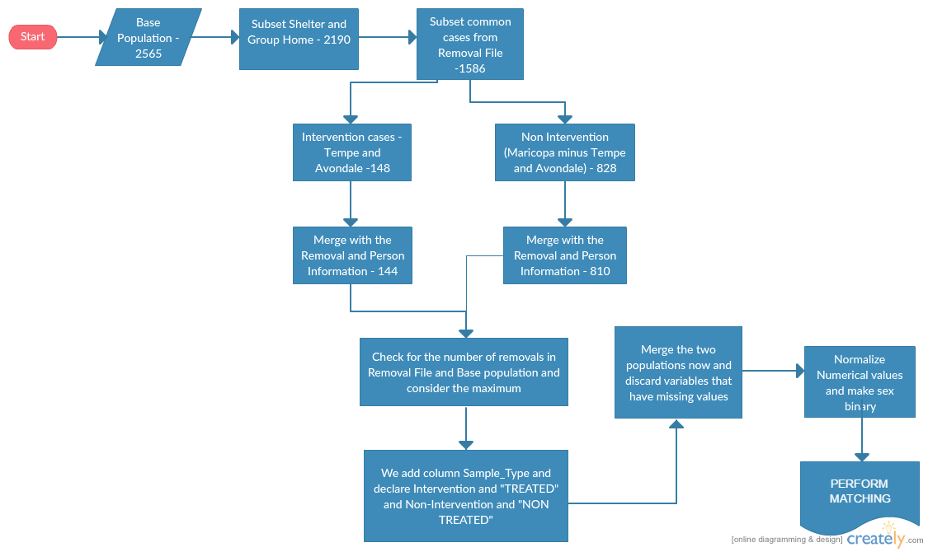

Figure :PSM flowchart

The various steps taken can be described in detail as given below: